
The Ivan Soulsbury Coast 2 Coast Walk
Sunday 7th September 2025
About
We are delighted and excited to be hosting our 8th annual “Coast 2 Coast” walk
The walk commences at 1.30pm prompt. You will be required to check in for the walk between 12.45 – 1.15pm at the NSC – we will be located at the Outdoor pitches reception
The walk will start with a lap of the outside track of the NSC and on to the old railway track then on through to the finish which is at the House of Mannanan
As the old railway line winds its way along you get a chance to savour some views and enjoy being really close to nature
The full walk distance over reasonable flat and gentle terrain is approximately 12 miles. For those who would like to take a shorter challenge (approximately 3 miles) we will have an alternative starting point at St.Johns in the car park by St Johns School commencing at 3.30pm with check in open at 3pm
Coast 2 Coast could be a challenging walk so it’s important you are confident that you are up to the task and this applies equally to any adult, supervised children or dogs who might be accompanying you on the day. (We will have water bowls available for your canine partners).
The old railway line is an active footpath with other users including cyclists and horses. We will have done a visual check of the footpath 24 hours prior to the walk but you must be mindful of hazards.
Please remember to wear clothing and footwear appropriate for the walk and weather
We will have marshals placed at a number of crossing points along the way. If you have any problems during the walk and can’t see a marshal please call the numbers given on the day for assistance.
We encourage the use of the What Three Words App should you need to be located
Any blind or visually impaired people will need to provide their own guide, if required.
All participants will need to check in with the marshals on arrival at their starting point (either the NSC or St Johns) and again at the end of the walk at the House of Mannanan.

Registering
All participants are required to register by completing our event registration form which can found from our Website page www.sightmatters.im or collected from our offices at Corrin Court, Onchan
Registrations must be submitted by 2nd September 2025
A sponsorship form for those wishing to raise funds for Sight Matters is available to download from our Website, or collected from our offices at Corrin Court
Everyone taking part will be given a digital certificate of achievement
Payment
The individual entrance fee for the event is £12.00 or children under 16 £5.00
Payment is made at the time of registration via Paypal. Alternatively it can be made by cash, card or chq (made payable to ‘Sight Matters’) at Corrin Court
Checkpoints
The route will have a number of refreshment stations to keep everyone well hydrated during the trek. Refreshment stations are located at both the start and finish and at the crossing points at Marown and St. Johns. There is also a free water refill station at the Western Amenity site along the footpath.
Toilets
A number of public toilet facilities are available on route at the NSC, Marown playing fields, St Johns village and Peel In addition there will be a portaloos available in St Johns and Marown
Parking
Parking is available at the NSC car park on Groves Road and the Pay and display at the Bowl. There is also limited free parking just behind the grandstand at The Bowl, and beside the Quarterbridge pub.
We are unable to use the car parks adjacent to the outdoor facilities
We suggest people requiring parking at Peel consider safely parking on the West Quay area. At St Johns the starting point is in the car park by St Johns School with limited parking.
We cannot provide transport for walkers
First Aid
First aid points are sited at each refreshment point.
Cancellation
We will advise the cancellation of the event in the case of bad weather or advice from emergency services using social media and via local media.
Route
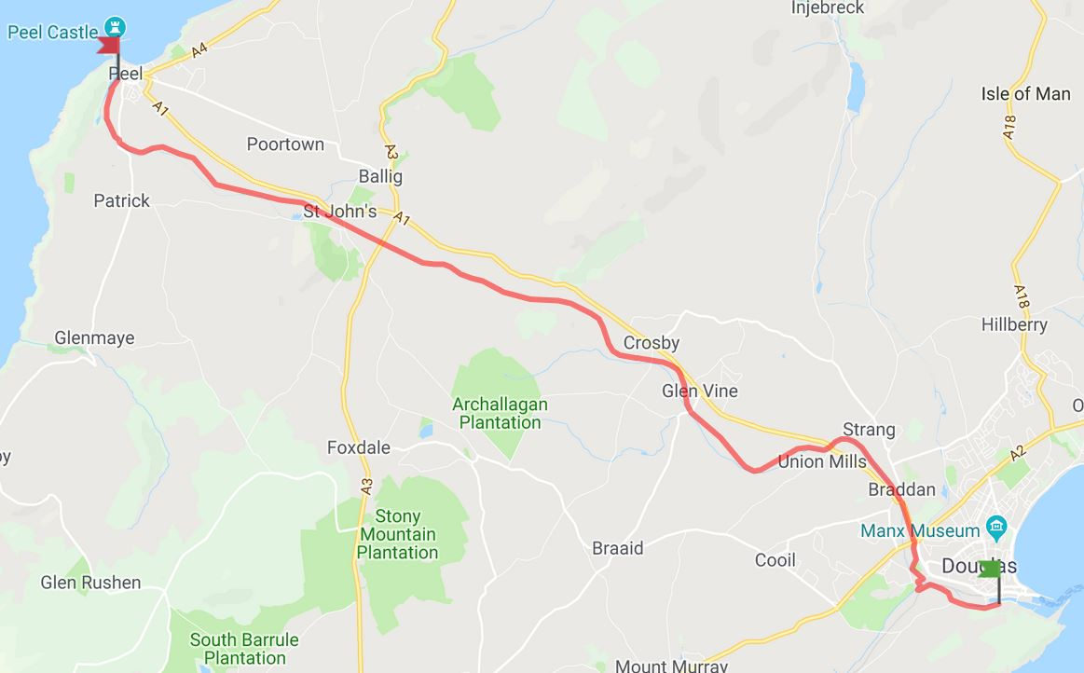

We start on the outside track of the NSC and do a lap before heading out towards Quarter Bridge.
Stewards at Quarter Bridge will again help walkers at the crossing point, where the route continues along the old railway line.
Further crossing points will also be staffed by stewards along the route, with water stations positioned in Marown and St. Johns.
The final crossing point in Peel will again be supervised by stewards, the walk will then be past the House of Manannan along the Quay to Peel
We will have walking marshalls from the NSC who will be advising the organisers of any possible hazards on route – they will be wearing a hi vis vest.
We will have back markers from the NSC who will be behind the last walkers.

www.sightmatters.im
Sight Matters is a trading name under Manx Blind Welfare Society
Manx Registered Charity No 132

